Java EE – Entreprise edition
Java EE framework depend on the framework java SE
make entreprise application using java SE is hardwork → solution is usage of java EE
main focus should be on “Business focus” more than the logical side(transaction, security, error handling, sql) when developing entreprise application.

Java SE specification
java SE framework comes with jdk

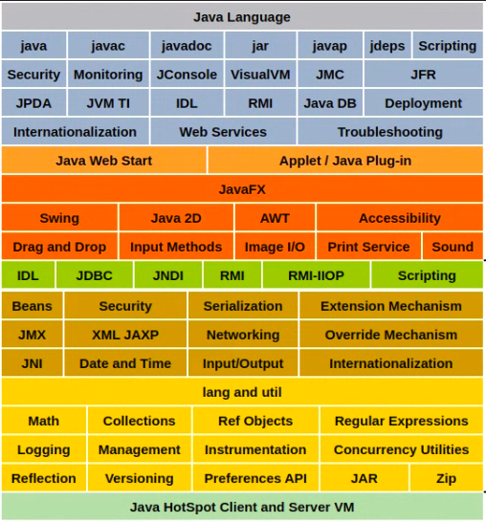
Java EE also collectio of specificatio like above

Implementation of java EE:-

01. GlassFish (open source)← have all the specifications of java EE / reference implementation

02. Oracle weblogic server ← implementation of java EE

03. WildFly (develop by red hat) (formar name = JBoss)← java EE application server

04. Apache TomEE ←

application server means ← all the specification of java EE have implemented
web containers ← implement several web specs (ex:- tomcat/ jety is light weight relative to tomcat)
Java EE web containers (open source web containers)

EJB container – heavy weight

web container is a collection of webserver and implementation of specs

two artifacts in java EE → WAR (wevArchive) , EAR (entreprise archive)

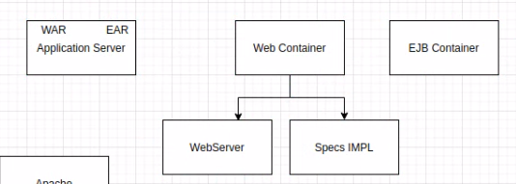

Example:- php
need a webserver and
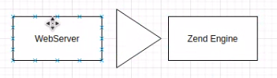

instead of this, install XAAMP

request comes to webserver, they only know to run static content. So, Zend engine/tomcat generate content dynamically. (ability to talk with back end and databases, wevserver cannot do that)

In-place deployment

edit configurations
double dhift
f9 + Enter

tool for check backend – Postman
http client
as well as in build http client availabe in intellij

